**Ideation Phase**

**Define the Problem Statements**

|  |  |
| --- | --- |
| Date | 16 June 2025 |
| Team ID | LTVIP2025TMID32984 |
| Project Name | CleanTech: Transforming waste management with transfer learning |
| Maximum Marks | 2 Marks |

**Customer Problem Statement Template:**

Create a problem statement to understand your customer's point of view. The Customer Problem Statement template helps you focus on what matters to create experiences people will love.

A well-articulated customer problem statement allows you and your team to find the ideal solution for the challenges your customers face. Throughout the process, you’ll also be able to empathize with your customers, which helps you better understand how they perceive your product or service.

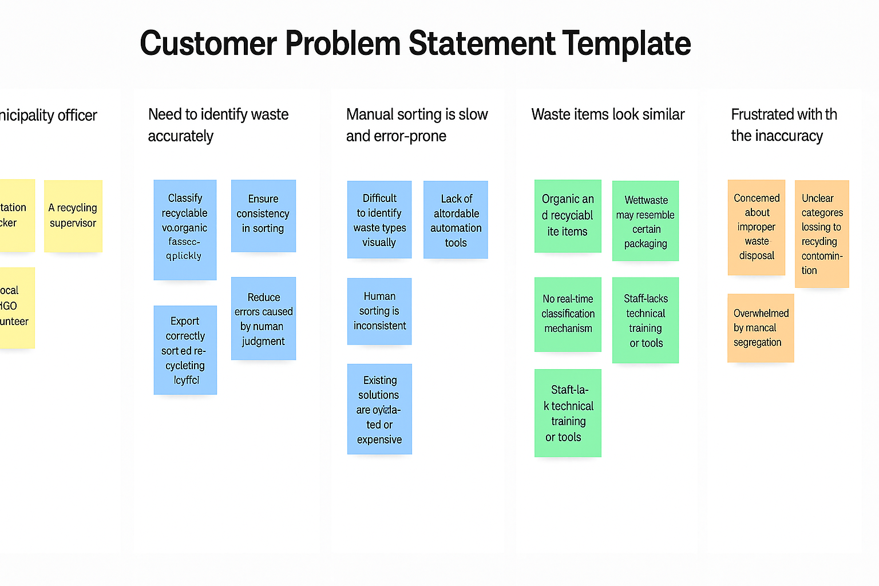

Reference: <https://miro.com/templates/customer-problem-statement/>

|  |  |  |  |  |  |
| --- | --- | --- | --- | --- | --- |
| **Problem Statement (PS)** | **I am (Customer)** | **I’m trying to** | **But** | **Because** | **Which makes me feel** |
| PS-1 | As a **municipal waste officer** | **efficiently sort and manage household waste** | manual classification is slow, inaccurate, and lacks consistency | there are no accessible AI-based tools or real-time waste identification systems | **frustrated and under-equipped to meet sustainability goals**. |
| PS-2 | As a **citizen** | properly dispose of my waste by category | I often don’t know how to identify the correct category | waste items look similar and there’s no simple tool to guide me | confused and discouraged from participating in eco-friendly practice |